Lab 4: Implementation of Dynamic/Interior Routing (RIP, OSPF)
Objective:
4.1) Implementation of Routing Information Protocol (RIP)
4.2) Implementation of Open Shortest Path First (OSPF)

Theory
1. Dynamic Routing
Dynamic routing is a routing method in which routers automatically learn and update network routes using routing protocols. Unlike static routing, it allows routers to adapt to changes in network topology and automatically select suitable paths for packet transmission.
Dynamic routing protocols are generally classified into:
- Interior Gateway Protocols (IGPs): Used for routing within a single Autonomous System (AS). Examples include RIP and OSPF.
- Exterior Gateway Protocols (EGPs): Used for routing between different Autonomous Systems. The most widely used EGP is BGP.
2. Routing Information Protocol (RIP)
RIP is a distance-vector interior gateway routing protocol (IGP) used to exchange routing information within an autonomous system. It uses hop count as its routing metric, where the route with the fewest hops is preferred. RIP supports a maximum of 15 hops, while a hop count of 16 represents an unreachable network. In Cisco Packet Tracer, RIP can be configured using commands such as router rip, network, and version 2.
3. Open Shortest Path First (OSPF)
OSPF is a link-state interior gateway routing protocol that determines the shortest path to a destination using the Shortest Path First (SPF) algorithm. Routers exchange link-state information to build a topology database and calculate optimal routes. OSPF uses cost as its routing metric and supports hierarchical network design using areas, with Area 0 commonly serving as the backbone area.
4. RIP and OSPF Configuration
The lab involves configuring routers with RIP and OSPF and advertising the connected networks so that routers can dynamically learn routes. After configuration, routing tables and network connectivity can be verified using Cisco IOS commands such as show ip route and connectivity-testing commands such as ping.

Components Required
- Cisco Packet Tracer
- 3 Routers (2901)
- 2 Switches (2960)
- PCs/Laptops
- Copper Straight-Through Cables
- Copper Cross-Over Cables
Procedure:
- Network Topology Setup
Steps
- Open Cisco Packet Tracer.
- Place three routers, two switches, and end devices.
- Connect:
- PCs to switches using Copper Straight-Through cables.
- Switches to routers.
- Routers to one another.
- Assign IP addresses to every router interface.
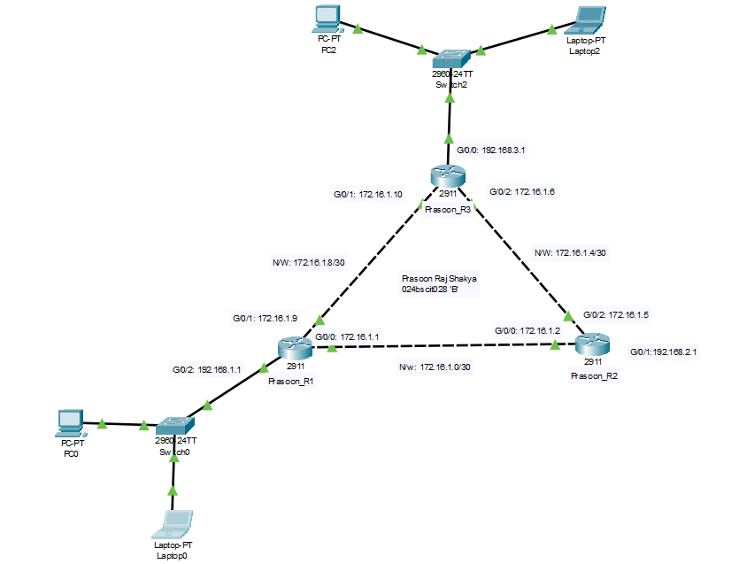
- Configure IP addresses on Router interface.
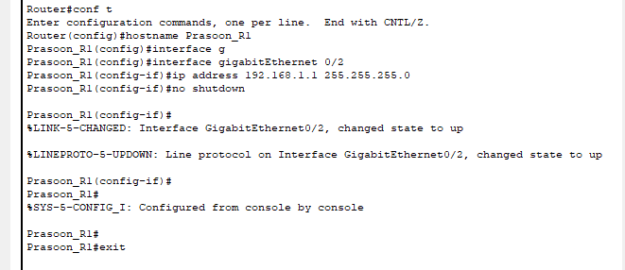
- Configure the DHCP service on the router for LAN 1 by creating a DHCP pool.
Prasoon_R1(config)#ip dh
Prasoon_R1(config)#ip dhcp pool LAN1
Prasoon_R1(dhcp-config)#network 192.168.1.1 255.255.255.0
Prasoon_R1(dhcp-config)#default-router 192.168.1.1
Prasoon_R1(dhcp-config)#dns-server 1.2.3.4
Prasoon_R1(dhcp-config)#exit
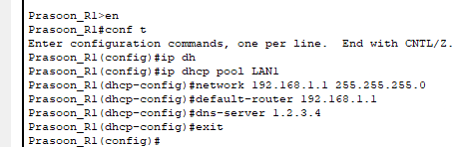
- Repeat the process for other routers
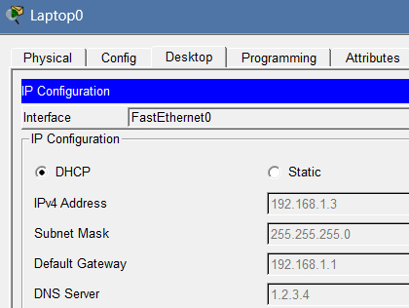
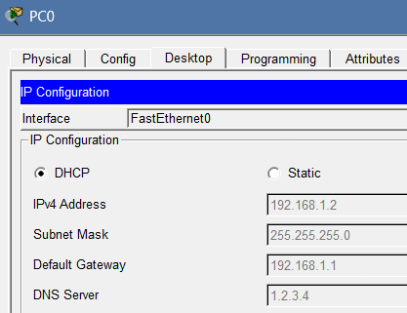
- Configure the PCs to obtain IP addresses automatically:

- Document each client’s received IP addresses.

IP Addressing Scheme
Device | Interface | IP Address | Subnet Mask | Connected To | Network
Prasoon_R1 | G0/0 | 172.16.1.1 | 255.255.255.252 | Prasoon_R2 | 172.16.1.0/30
Prasoon_R2 | G0/0 | 172.16.1.2 | 255.255.255.252 | Prasoon_R1
Prasoon_R2 | G0/1 | 172.16.1.5 | 255.255.255.252 | Prasoon_R3 | 172.16.1.4/30
Prasoon_R3 | G0/1 | 172.16.1.6 | 255.255.255.252 | Prasoon_R2
Prasoon_R1 | G0/2 | 172.16.1.9 | 255.255.255.252 | Prasoon_R3 | 172.16.1.8/30
Prasoon_R3 | G0/2 | 172.16.1.10 | 255.255.255.252 | Prasoon_R1
Prasoon_R1 | G0/1 | 192.168.1.1 | 255.255.255.0 | Switch0 (LAN1) | 192.168.1.0/24
Prasoon_R3 | G0/0 | 192.168.2.1 | 255.255.255.0 | Switch1 (LAN2) | 192.168.2.0/24

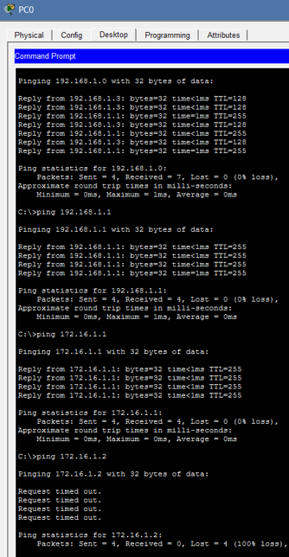
- Routing Information Protocol
Verifing interface connectivity by pinging directly connected networks.
Ping Test Results from PC0
- Pinging 192.168.1.0 from 192.168.1.2: Successful
- Pinging 192.168.1.1 from 192.168.1.2: Successful
- Pinging 172.16.1.1 from 192.168.1.2: Successful
- Pinging 172.16.1.2 (Prasoon_R2) from 192.168.1.2:
Unsuccessful (Request timed out; 100% packet loss)

Here, remote networks cannot be reached because routing information is unavailable.

Procedure:
- Configure RIP routes on Prasoon_R1 to reach LAN 1, Prasoon_R2 and Prasoon_R3.
  - To initially check the static route status use: sh ip route
  - To establish connection use:
Prasoon_R1>en
Prasoon_R1#conf t
Enter configuration commands, one per line. End with CNTL/Z.
Prasoon_R1(config)#router rip
Prasoon_R1(config-router)#version 2
Prasoon_R1(config-router)#network 192.168.1.0
Prasoon_R1(config-router)#network 172.16.1.0
Prasoon_R1(config-router)#network 172.16.1.8
Prasoon_R1(config-router)#
- Configure RIP routes on Prasoon_R2 to reach Prasoon_R1 and Prasoon_R3.
    - To initially check the static route status use: sh ip route
    - To establish connection use:
Prasoon_R2 # conf t
Prasoon_R2 (config) # router rip
Prasoon_R2 (config-router) # version 2
Prasoon_R2 (config-router) # network 172.16.1.0
Prasoon_R2 (config-router) # network 172.16.1.4
Prasoon_R2 (config-router) # exit
Prasoon_R2 (config) # exit
Prasoon_R2 # wr
- Configure RIP routes on Prasoon_R3 to reach LAN 2, Prasoon_R2, and Prasoon_R1.
  - To initially check the static route status use: sh ip route
  - To establish connection use:
Prasoon_R3 # conf t
Prasoon_R3 (config) # router rip
Prasoon_R3 (config-router) # version 2
Prasoon_R3 (config-router) # network 172.16.1.0
Prasoon_R3 (config-router) # network 172.16.1.4
Prasoon_R3 (config-router) # exit
Prasoon_R3 (config) # exit
Prasoon_R3 # wr
- Ping devices located on the opposite network to test the connection

Pinging 172.16.1.2 (Prasoon_R2) from 192.168.1.2:Successful
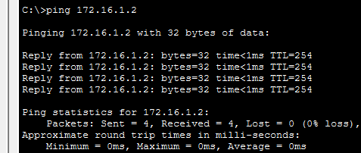
Pinging 192.168.2.2 from 192.168.1.2:Successful
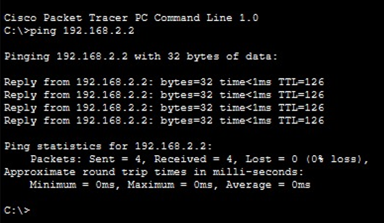

Observations
RIP Version 2 was successfully configured on all routers, enabling the automatic exchange of routing information. After configuration, the routers learned remote networks dynamically, and communication between different LANs was successfully established and verified using the ping command.

Conclusion
RIP Version 2 was successfully configured and implemented in Cisco Packet Tracer. The routers exchanged routing information dynamically, allowing communication between different networks. The successful ping tests confirmed that the configured routes were working correctly.

4.2) Implementation of Open Shortest Path First (OSPF)\
Procedure
  - Network Topology Setup
Steps:
- Open Cisco Packet Tracer.
- Place three routers, two switches, and end devices.
- Connect:
- PCs to switches using Copper Straight-Through cables.
- Switches to routers.
- Routers to one another.
- Assign IP addresses to every router interface.
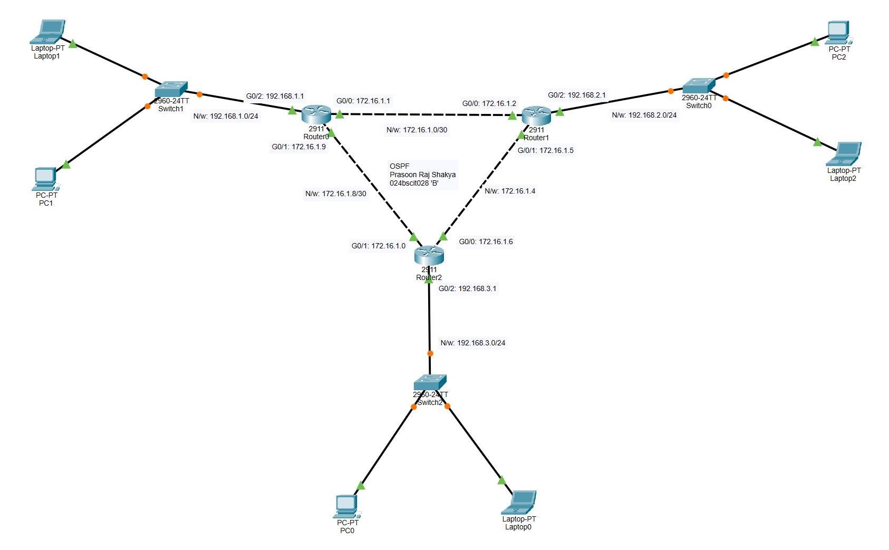
- Configure IP addresses on Router0 interface.
Router>en
Router#conf t
Enter configuration commands, one per line. End with CNTL/Z.
Router(config)#interface gigabitEther
Router(config)#interface gigabitEthernet 0/2
Router(config-if)#ip address 192.168.1.1 255.255.255.0
Router(config-if)#no shutdown
Router(config-if)#
%LINK-5-CHANGED: Interface GigabitEthernet0/2, changed state to up
%LINEPROTO-5-UPDOWN: Line protocol on Interface GigabitEthernet0/2, changed state to up
Router(config-if)#exit
Router(config)#ip dhcp pool LAN0
Router(dhcp-config)#network 192.168.1.1 255.255.255.0
Router(dhcp-config)#default-router 192.168.1.1
Router(dhcp-config)#dns-server 1.2.3.4
Router(dhcp-config)#exit
Router(config)#interface gigabitEthernet 0/0
Router(config-if)#ip address 172.16.1.1 255.255.255.252
Router(config-if)#no shutdown
Router(config-if)#
%LINK-5-CHANGED: Interface GigabitEthernet0/0, changed state to up
Router(config-if)#interface gigabit
Router(config-if)#interface gigabitEthernet 0/1
Router(config-if)#ip address 172.16.1.9 255.255.255.252
Router(config-if)#no shutdown
Router(config-if)#
%LINK-5-CHANGED: Interface GigabitEthernet0/1, changed state to up
Router(config-if)#exit
Router(config)#hostname Prasoon_R0

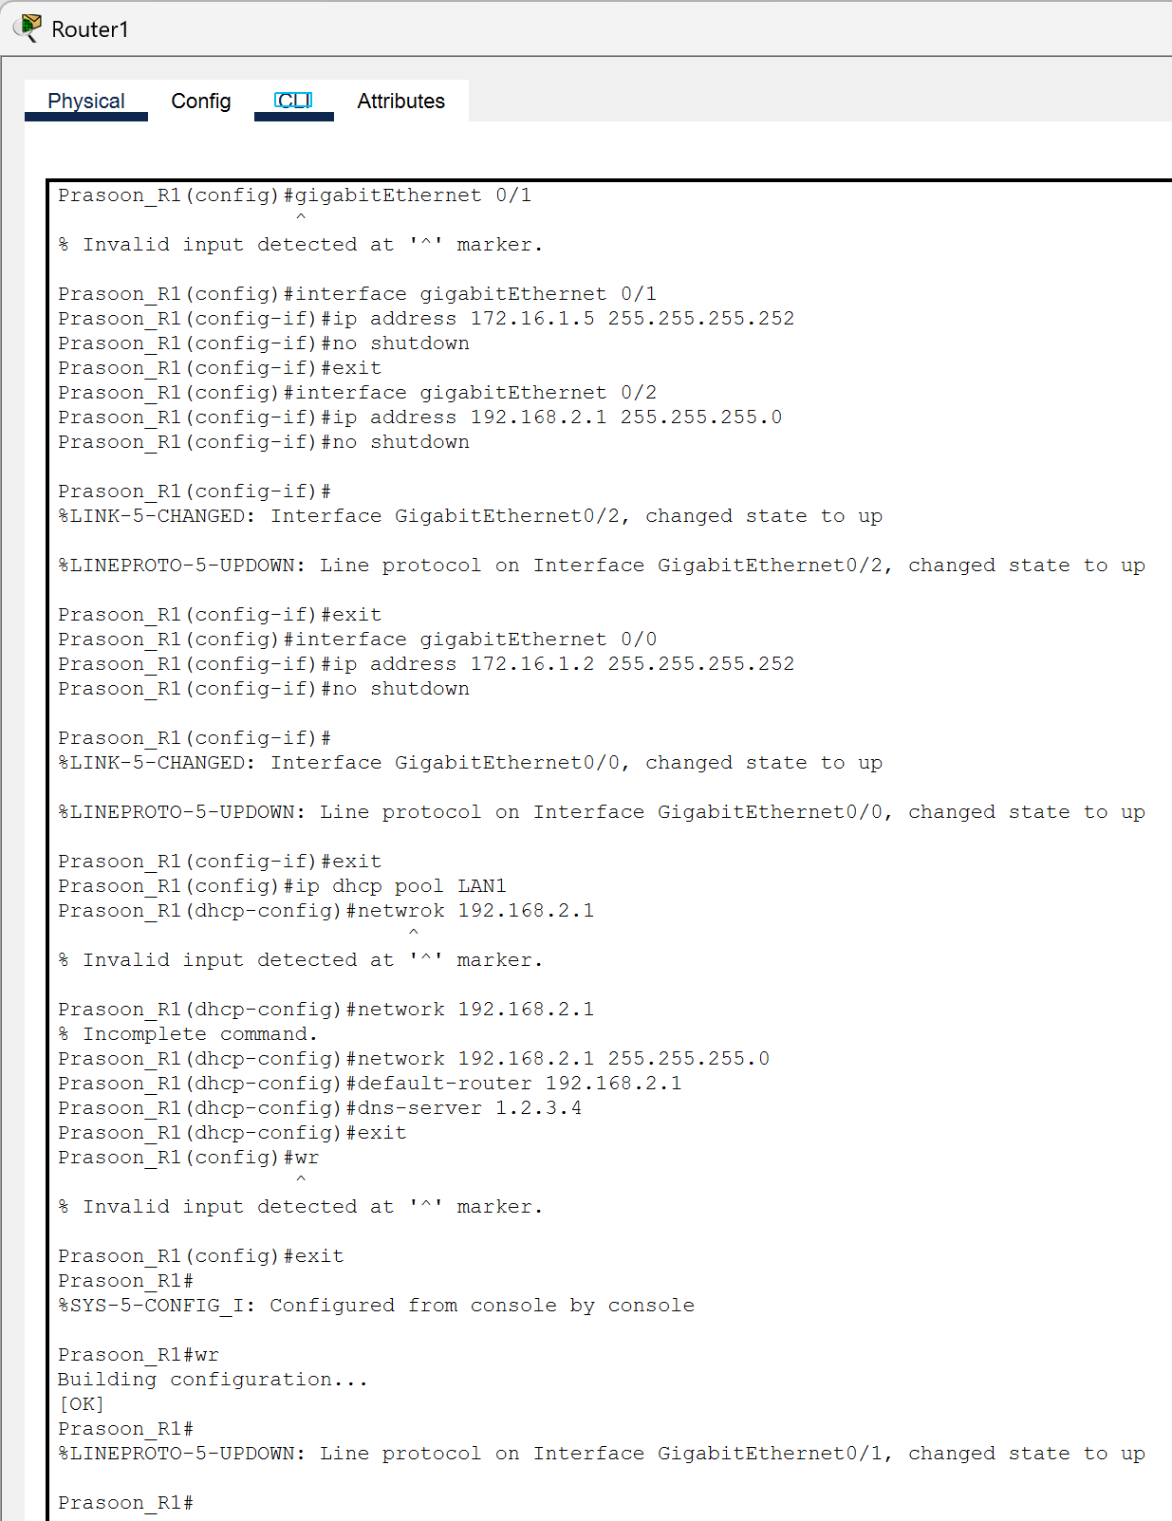
- Repeat all of this for Prasoon_R1 (Router1) and Prasoon_R2 (Router2).
- Document each client’s received IP addresses.

IP Addressing Scheme
Device | Interface | IP Address | Subnet Mask | Connected To | Network
Prasoon_R0 | G0/0 | 172.16.1.1 | 255.255.255.252 | Prasoon_ R1 | 172.16.1.0/30
Prasoon_R1 | G0/0 | 172.16.1.2 | 255.255.255.252 | Prasoon_R0
Prasoon_R1 | G0/2 | 172.16.1.5 | 255.255.255.252 | Prasoon_R2 | 172.16.1.4/30
Prasoon_R2 | G0/2 | 172.16.1.6 | 255.255.255.252 | Prasoon_R1
Prasoon_R0 | G0/1 | 172.16.1.9 | 255.255.255.252 | Prasoon_R2 | 172.16.1.8/30
Prasoon_R2 | G0/1 | 172.16.1.10 | 255.255.255.252 | Prasoon_R0
Prasoon_R0 | G0/1 | 192.168.1.1 | 255.255.255.0 | Switch0 (LAN1) | 192.168.1.0/24
Prasoon_R1 | G0/1 | 192.168.2.1 | 255.255.255.0 | Switch1 (LAN2) | 192.168.2.0/24
Prasoon_R2 | G0/0 | 192.168.3.1 | 255.255.255.0 | Switch2 (LAN3) | 192.168.3.0/24

Network after successful configuration
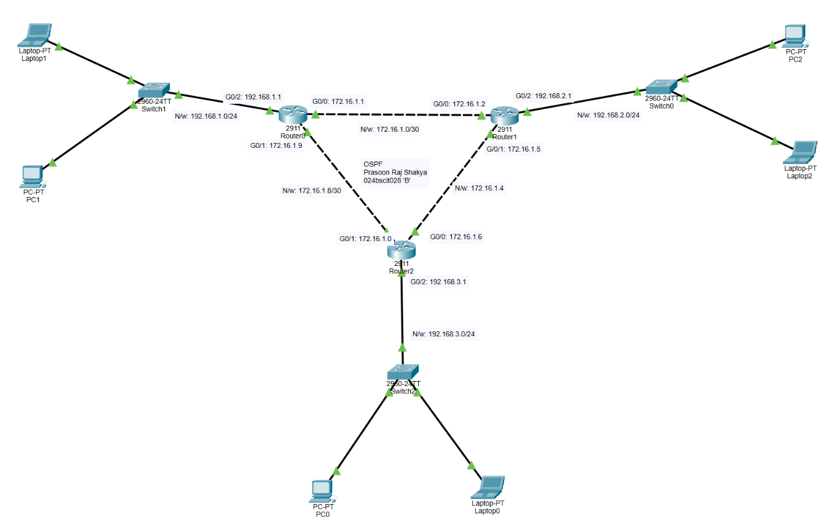

- Open Shortest Path First (OSPF)
- Configure OSPF routes on Prasoon_R0 to reach LAN 1, Prasoon_R1 and Prasoon_R2.
Prasoon_R0#conf t
Enter configuration commands, one per line. End with CNTL/Z.
Prasoon_R0(config)#router ospf 1
Prasoon_R0(config-router)#network 192.168.1.0 0.0.0.255 area 0
Prasoon_R0(config-router)#network 172.168.1.0 0.0.0.3 area 0
Prasoon_R0(config-router)#network 172.168.1.8 0.0.0.3 area 0
Prasoon_R0(config-router)#exit
Prasoon_R0(config)#exit
Prasoon_R0#
%SYS-5-CONFIG_I: Configured from console by console
Prasoon_R0#wr
Building configuration...
[OK]
Prasoon_R0#

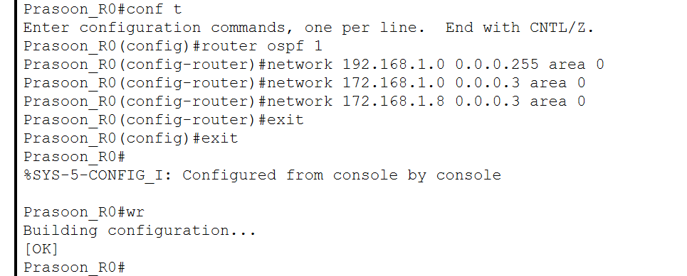

- Similarly, configure OSPF routes on Prasoon_R1 and Prasoon_R2 to reach the other routers

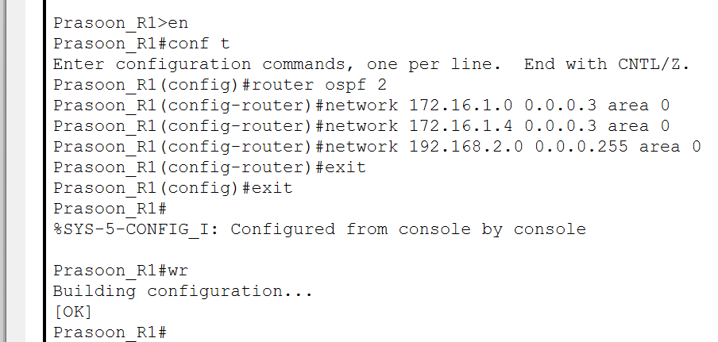

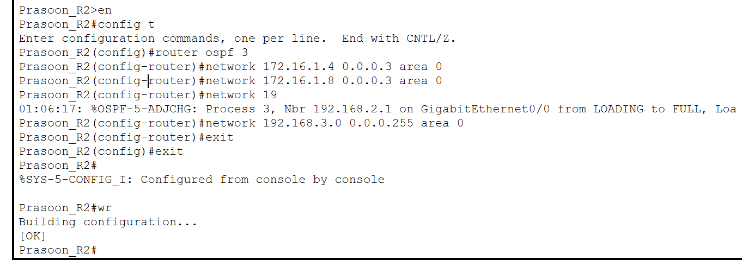

- Ping devices located on the opposite network.

From 192.168.1.2 (PC0) – Pinging 172.16.1.2 (Prasoon_R1) – (SUCCESS)


From 192.168.1.2 (PC0) – Pinging 192.168.2.2 (PC2) – (SUCCESS)
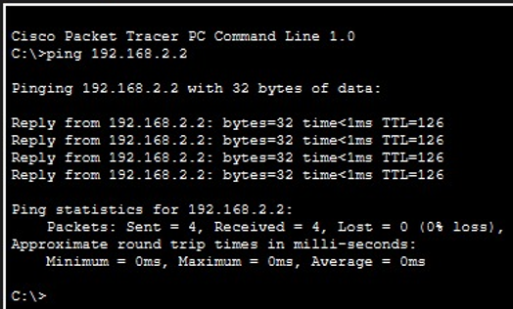

From 192.168.1.2 (PC0) – Pinging 192.168.3.1 (Prasoon_R2) – (SUCCESS)
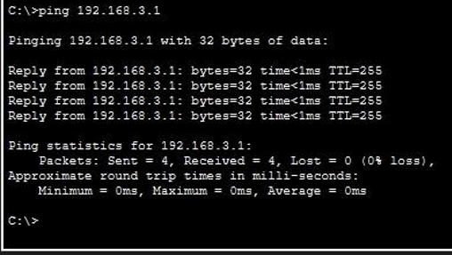

Observations
RIP Version 2 and OSPF were successfully configured on the routers in Cisco Packet Tracer. Both routing protocols enabled the routers to automatically exchange routing information and learn remote networks dynamically. OSPF established neighbor relationships within Area 0 and used the SPF algorithm to determine optimal paths, while RIP dynamically updated routing tables through periodic routing information exchange. Successful ping tests confirmed proper packet forwarding and connectivity between the different networks.

Conclusion
RIP Version 2 and OSPF were successfully implemented in Cisco Packet Tracer, demonstrating the use of dynamic routing to establish communication between different networks without manual route configuration. Both protocols successfully maintained routing information and enabled end-to-end connectivity. The experiment also demonstrated that OSPF uses link-state information and SPF to select optimal paths, while RIP uses a simpler distance-vector approach, making them suitable for different network requirements.

